AIMWebManager

eCommerce Platform



Automated Information Management, Inc.

Rev. March 6, 2003

Confidentiality Statement
This proposal and all its contents and attachments is STRICTLY CONFIDENTIAL AND PROPRIETARY. It is to be used only for internal evaluation purposes. Under no circumstances should this document or any attachments be released, reviewed or copied without prior written permission of Automated Information Management, Inc.
.

©2002-2003 Automated Information Management, Inc., All Rights Reserved.

Introduction 1
Why is AIMWebStore better than other ecommerce products? 2
Take a tour of the features with screenshots. 3
Create your home page 3
Create Your Catalog 4
Categories and Subcategories 4
Products and Options 5
Shopping Cart 6
Customer Information Management 7
Login 7
Customer Billing Information 8
Shipping Options 9
Inventory Control 9
Payment Manager 9
Store Administration 10
Order Manager 10
Store Manager 13
Product Manager 14
Standard Options 18
Discount Manager 19
Gift Certificates 20
Tax Manager 20
Shipping Manager 21
Payment, Merchant Account Manager 24
Page Manager 25
Search Manager 27
User Manager 28

COPYRIGHT AND INTELLECTUAL PROPERTY NOTICE:
This is a proprietary work created by Automated Information Management, Inc., and various third parties. It is confidential and is only for the expressed limited purpose of evaluating Automated Information Management, Inc. and its products, tangible and otherwise. The contents, including, but not limited to concepts, designs, drawings and evaluations, are the property of Automated Information Management, Inc. and may not be used without its permission. AIMWebStore is a trademark of Automated Information Management, Inc.
© 2002-2003 Automated Information Management, Inc. All rights reserved.

Introduction
AIMWebStore is designed for the small to medium-sized merchant and for the web developer that wants plenty of features, but a product they can easily customize as well. Here's what AIMWebStore offers:
- Store works without JavaScript or cookies
- Customize your store with headers, footers and style sheets
- Easy to use web-based Administrator
- Built-in help files
- Unlimited number and level of categories
- Unlimited number of products
- Products and subcategories at any level
- Special quick-edit screens for products and categories
- Mark products and/or categories as "New" or "On Sale"
- Special product copy feature to make adding similar products quick and easy
- Unlimited number of product options
- Options can adjust product price, weight, SKU and number in stock
- Turn options or option choices on and off
- Automatic display of price with option
- Standard options that can be used for multiple products
- Can make an option choice required or not
- Custom fields for adding information on products such as manufacturer, author, etc.
- Ability to set a second set of prices for special users (e.g. wholesalers)
- Tax rates by state, zip and/or country
- Setting for tax on shipping
- Automatic shipping rates for UPS and USPS, others using Intershipper
- Alternatively, can create custom shipping tables by weight, number of items, or total price
- Can add a base shipping charge to all orders
- Can add a handling charge to all orders
- Choose the types of shipping you want to offer (ground, next-day, etc.)
- Send confirmation emails when orders are placed and shipped
- Offer discounts by product, category, or the entire store
- Can also base discount on total amount of order
- Discounts can be based on a coupon code that customer must enter
- Offer discounts only to certain customers
- Discounts can be a specific amount off, or a percentage
- Discount can be offered if certain amount spent, or specific quantity purchased
- Create and redeem gift certificate codes
- Customers can add gift messages and desired delivery date to orders
- Shortcut features to make order processing fast and easy
- Use with Cybercash, ICVerify, EZIC, Linkpoint, Authorize.Net and Verisign, other processors possible as well
- Checks for valid credit card number and expiration date
- Built-in pop-up editor for lengthy text fields
- Can also easily integrate with Activedit
- Image upload feature
- Store calculates all image widths and heights
- Add your own additional store pages
- Create and track store affiliates
- Send email to subscribers, affiliates, or other user groups
- Inventory control settings
- Several store reports to track sales, best-selling products, affiliate earnings, etc.
- Customers can view orders and order status
- Affiliates can sign up and view reports
- Choose from Verity® or SQL-based search
- Can use for non-store applications
- Full source code included when purchased

Why is AIMWebStore better than other ecommerce products?

Picking the right store product is not always an easy task. Don't assume that because a store is more popular, higher-priced, or has more features, that it is better for you. Sometimes it's the details that matter in the long run, not the things that are obvious up front. Here are some things that put AIMWebStore ahead of the competition:
- No limits on category levels, products, or options
- Administrator takes you right to the current orders, saving time
- Can process multiple orders at once, more time saved!
- Can print multiple orders at once
- Use of style sheets to extensively control look of store is fast and easy
- Store outputs image width and height tags automatically (some stores just leave them out!)
- Extremely flexible and powerful discounts
- Extremely flexible and powerful product options
- Assigning the same product to multiple categories saves time and errors
- Use of standard options saves time and errors
- Use of custom fields limits custom work that has to be done
- Product copy feature makes adding lots of similar products super-fast!
- Products and categories can be moved or re-organized so you don't have to re-enter them
- Category and product quick lists save tons of time when updating information like number in stock
- Commented and easy-to-follow code makes customizing simple, saving tons of time and money
- Internal UPS rate tables so you don't have to rely on another server being up
- Affiliate features help increase your sales
- All session and application variables fully locked for better stability
- Minimal use of session variables for better scalability
- Optimized for search engine submissions to bring in more customers
- Related product feature for cross-selling to increase sales
- Many additional features like coupons, gift certificates, gift messages, etc. included for free!
- Excellent error handling (your customer will never see a nasty Cold Fusion error!)
- And much more!

Take a tour of the features with screenshots.

Create your home page
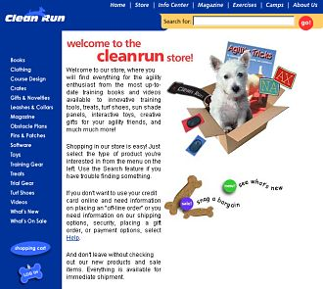

Start by creating your home page. Create your own “look and feel” with your own custom headers and footers with graphical links to the main store categories, or allow AIMWebStore to create the links itself. Display store specials and discounts, and use the store settings to pick your store colors, background, lines and more.

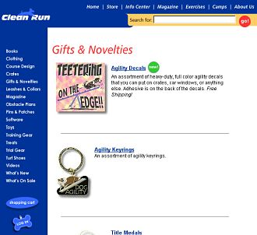

Create Your Catalog

Categories and Subcategories
The individual category pages of the store are dynamically generated from the information in the database, including title graphics, individual product information and images, subcategories, discounts, etc. The store allows you to have as many levels of categories as you want, and products can appear at any level.

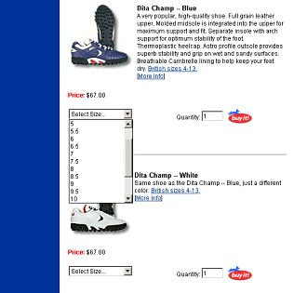

Products and Options
Products can have any number of options. Options can adjust the price, weight, and SKU of the product, and can even be used for inventory tracking. Or use a text box option for entering things like monogramming. A product can have a detailed information page, in which case a link will automatically be displayed on the category page. You can choose to turn on or off the display of prices, discounts, retail prices, quantity in stock, etc. as well as turn choices or entire options on and off.



Your descriptions can contain HTML markup to further customize the look of your store, and use the 4 different image settings for both products and categories to create a great-looking store!

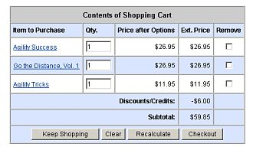

Shopping Cart
AIMWebStore stores the customer's cart in temporary database tables. This minimizes the amount of server memory being used by your store and allows for the best scalability. Once the order is completed, the information is copied into the permanent order tables. You can easily clear the temporary tables of old data just by clicking a button in the Administrator. At any time, the customer can view their cart, to see their current order subtotal, make changes to the quantities, remove items, or completely clear the cart. You can change the default colors used to match your store.

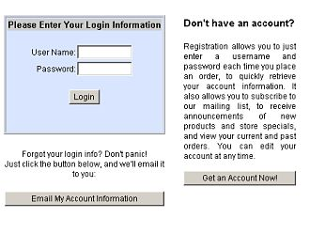

Customer Information Management

Login
AIMWebStore includes the ability for your customers to create their own login account, so they can easily retrieve their customer information when placing an order, view previous orders, and subscribe to your mailing list. Login accounts also allow you to offer discounts to selected customers or allow visitors to sign up as a store affiliate.

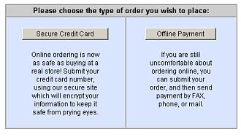

You have lots of choices about how to accept orders in your store. You can require credit cards, to allow online credit card processing like CyberCash or Authorize.Net, or you can provide an option for customers to submit their order and then call or mail their payment in. Don't have a merchant account? AIMWebStore allows you to disable the credit card section completely.

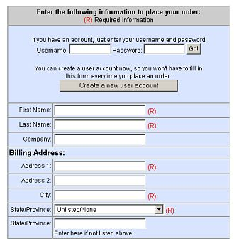

Customer Billing Information
Customers enter their billing information, and separate shipping information, if need be. Both are easily retrieved on the form with the account login. Customers can also choose to have a cookie saved that will automatically retrieve their information the next time they place an order, and can enter information like gift card message, coupon or gift certificate codes, and delivery date.

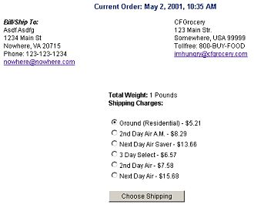

Shipping Options
You have several choices for handling the shipping in your store. You can use automatic shipper rates, or create custom tables for shipping based on total amount spent, total weight, or number of items. You can provide your customer with various options for shipping, add a base amount or handling percentage, and even have items in your store that are exempt from shipping charges (like magazine subscriptions). You can add a specific fee for other countries, display a custom message describing your policy, or disable orders from other countries completely.

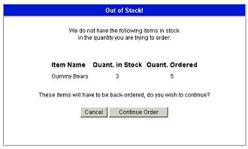

Inventory Control
Use Inventory Control to disallow backorders or warn customers of out-of-stock items. You can have the store automatically remove items that are out-of-stock from displaying in the store. Alternatively, use inventory control at the Administrator level to avoid problems with fake orders.

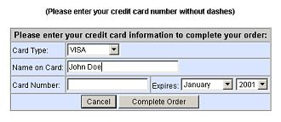

Payment Manager
Choose the types of credit cards you accept and setup any online processing. The store has built-in handling for Cybercash, Authorize.Net, Linkpoint, EZIC, Verisign and ICVerify. Just install the proper Cold Fusion tag, enter your settings and go!

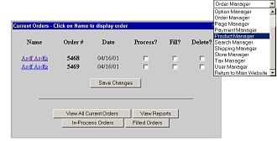

Store Administration
The Administrator is the main control panel for AIMWebStore. From here, you can view current orders, change the settings of your store, add and edit products and categories, and much more!

Order Manager
The Administrator defaults to the Order Manager, so you can quickly log in and view your current orders, fill in-process orders, view filled orders, and view store reports.

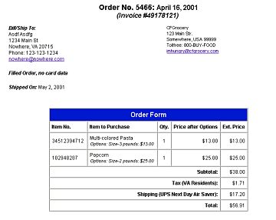

You can view a copy of the invoice for current orders or past orders, as well as print out batches of orders. The invoice contains all the information on the order including shipping date, coupon or gift certificate code, affiliate for the order, and more.

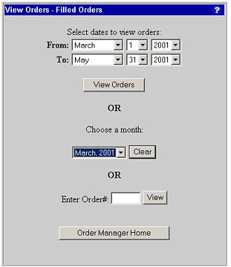

Select any range of dates you wish to view In-Process or Filled orders for, or enter the Order Number to find it immediately. You can also purge a full month of filled orders to clean out your database.

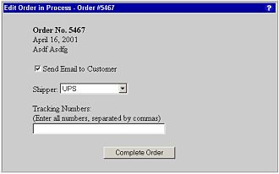

Use the In-Process order feature in order to send a separate email to your customers when their order is filled and shipped. You can include tracking numbers along with the email.

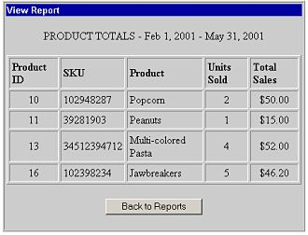

The Order Manager also includes a number of store reports, such as order summaries, top selling products, tax collected, affiliate reports and more.

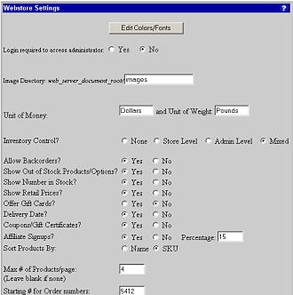

Store Manager
To set up your store, first visit the Store Manager. This is where you control most of the main settings of the store, such as the colors and fonts, main store images, secure and non-secure URLs, inventory control, merchant information, home country, etc.

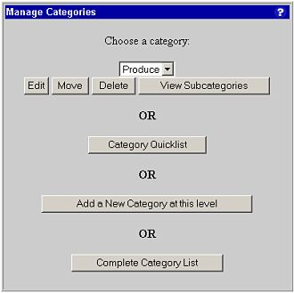

Next, visit the Category Manager to set up your store categories. You can also delete categories, and even move a category, and all its associated products, under another category.

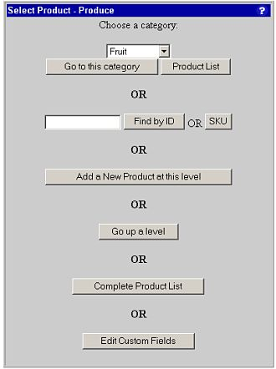

Product Manager
The Product Manager is where you will add and edit individual products in your store. Drill-down through the categories of the store to the level the product is at, or use the Product List feature for quick edits.

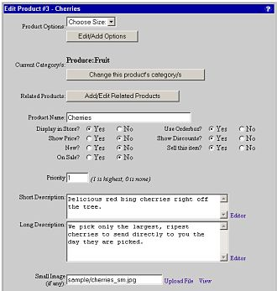

This is the first half of the Product Edit screen. At the top, any current options for the product are displayed, you can edit or remove these at any time. You can also assign the product to multiple categories, or move it around in the store. Add related products for cross-selling. You can turn the product off in the store (useful for seasonal items) and control how it will display. Descriptions can include HTML for further customization.

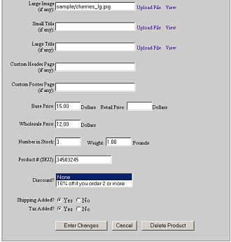

This is the second half of the Product Edit screen. Each product (and category) can have 4 images associated with it, which are used when generating the store pages. You can also set the product's base price, retail price, wholesale price, base weight, number in stock, and SKU#. If any product-level discounts have been created, you can assign them here. Custom product fields you create will also be shown.

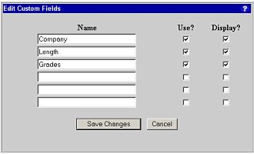

Product custom fields allows you to add your own fields to your product information screens. These fields can be used in a variety of ways, from simply adding additional information, to custom additions like downloadable products or advanced search fields.

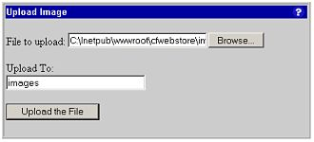

If your ISP allows the use of CFFILE actions (AIM as your ISP does), images in the store can be directly uploaded through the Administrator. Once the upload is complete, the filename will automatically be filled in on the edit form for you.

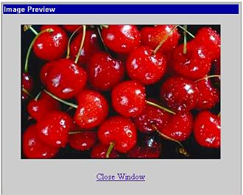

Images that have been uploaded to the server can also be viewed using the Image Preview feature.

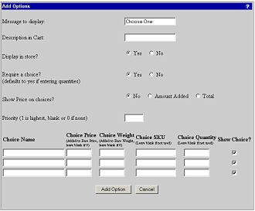

Adding options to your product is a simple matter. Just tell the store how many choices you need, and it will create the form for you. Enter the message to display on the top of the drop-down list, the message for each choice, adjustment to the price and/or weight, SKU for the option and number in stock if used.

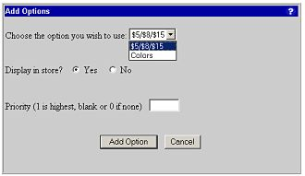

Standard Options
You can also create standard options that can be applied to multiple products in your store. Standard options save you from having to edit options on many products...just edit the standard option and all products using it will be updated automatically.

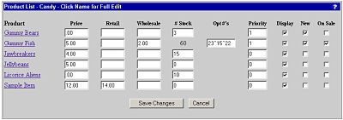

The Product List can be used for quick edits of common things like prices, number in stock, priority and whether to display the product or not. If you use options to track inventory, you can even edit those here as well. Just click on the product name to go to the complete Edit screen.

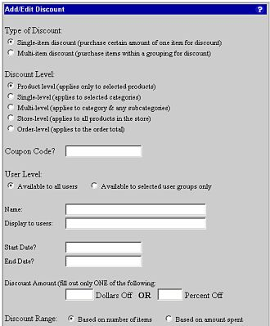

Discount Manager
AIMWebStore can do very complex types of discounts. First, decide if this discount is based on purchasing a certain amount of one item, or from a group of items. Next, determine if the discount is applied on a per-product basis, to single categories, to a category and any subcategories, to the entire store, or to the order total. Then decide if the discount is a specific amount of money off, or a percentage. You can set a range of dates to apply the discount, and require a coupon code to receive it. Lastly, set whether the discount is based on the number of items purchased, or the amount of money spent on them. You can even make a discount available only to certain users.

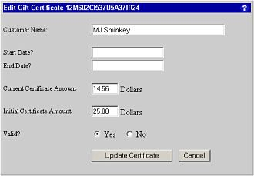

Gift Certificates
You can sell and generate gift certificates with AIMWebStore. Just enter the amount for the certificate and the store will generate a code for you. Customers can then use the code when placing a future order.

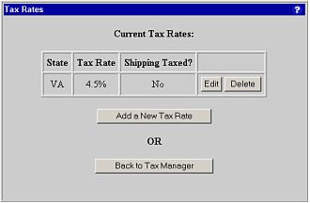

Tax Manager
Use the Tax Manager to set up the states to collect tax from. You can also set a country tax rate for countries like Canada.

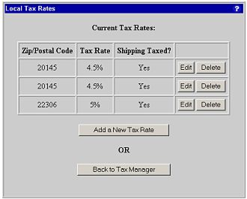

You can also create local tax rates based on the postal code of the customer.

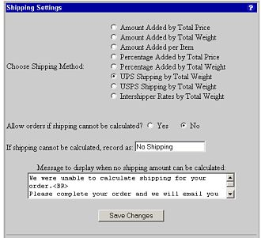

Shipping Manager
The Shipping Manager in AIMWebStore has a number of sections to fully customize shipping for your store. First determine the type of shipping to use; automatic UPS, USPS or Intershipper rates, or custom shipping tables based on price, weight, or number of items. Next, decide if you will allow orders for which shipping cannot be determined (generally international orders). For such orders, you can display a specific message alerting users that the invoice for their order will not include shipping, and what your policy in such cases is.

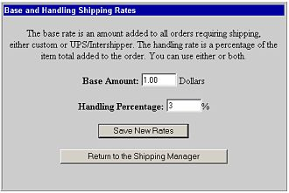

You can set a base shipping rate which will be added to all orders with shipping charges and/or a handling charge that adds a percentage of the order.

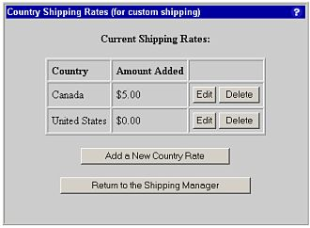

Country rates are used with the custom shipping tables. This allows you to set a specific dollar amount to be added for orders to certain countries, which is added to the shipping amount determined by the shipping table.

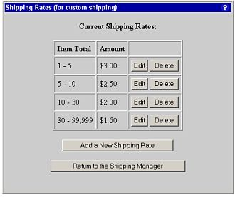

For custom shipping methods, you will need to set up your shipping table. Create price, weight or item ranges, and assign a shipping amount to that range.

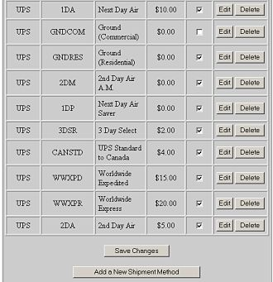

The Shipping Methods table is used for all types of shipping. This allows you to choose what types of shipping are available to your customers. If only one method is used, the shipping amount will be automatically chosen, otherwise, the customer will receive a list of choices. You can use the built-in methods or add your own.

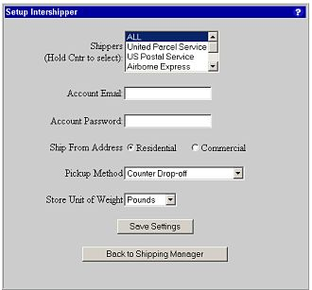

For shipping methods like Intershipper and USPS, you will need to configure your settings and register for an account.

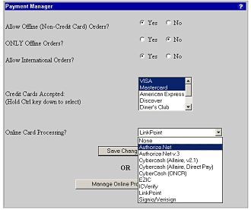

Payment, Merchant Account Manager
Use the Payment Manager to determine how the store will handle order payments. You can allow offline orders for customers who prefer to call in or FAX their credit card information or mail payments. Choose from a list of credit cards to accept, or if you can't accept credit cards, set the store for only offline orders. Choose what type of online credit card validation to use, or set to None to handle processing offline.

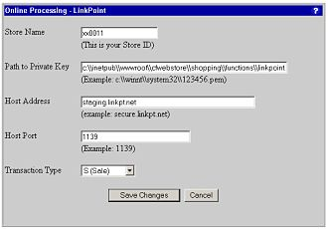

For online processors, you will need to enter your configuration information, such as your merchant name, server, passcode, etc.

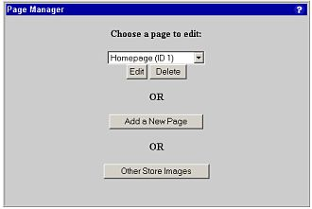

Page Manager
The Page Manager allows you to easily customize several main pages in the store, or to add your own pages for extra information.

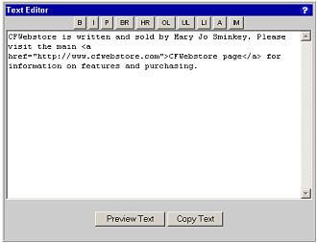

You can use this pop-up editor window for simple HTML editing of your pages, or for product and category descriptions.

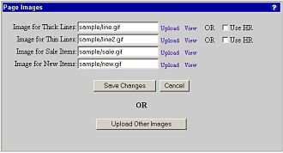

The Page Manager is also where you configure several images for your store, as well as upload any other extra images you might need.

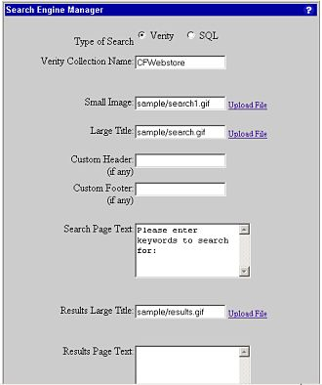

Search Manager
The Search Manager is used to set up the type of search you wish to use, either a standard SQL search, or a full-featured Verity search. You can set up the Verity Collection name to use, reindex the collection, and customize the search and results page here.

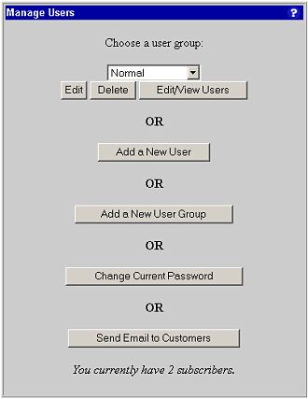

User Manager
Create and edit user groups in the User Manager. User groups are mainly used to assign user-level discounts, or to add additional administrators for your store. You can also change the current Administrator's password here, create store affiliates and send email to users.

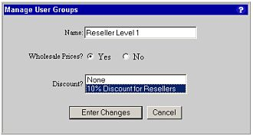

You can create special user groups that receive certain discounts and/or wholesale prices. Add users to the group for them to receive the special pricing.

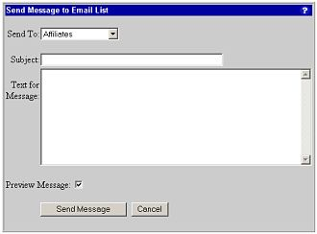

You can send email to subscribed users, specific user groups, or affiliates.

